Joel Atkinson
October 30, 2024
CSD420 Advanced Java Programming
Assignment 2.2

Code for the WriteData program:
import java.io.BufferedWriter;
import java.io.FileWriter;
import java.io.IOException;
import java.util.Random;
public class WriteData {
public static void main(String[] args) {
Random rand = new Random();
int[] intArray = new int[5];
double[] doubleArray = new double[5];
// Generate random integers (0 to 99)
for (int i = 0; i < 5; i++) {
intArray[i] = rand.nextInt(100);
}
// Generate random doubles (0.0 to 99.9)
for (int i = 0; i < 5; i++) {
doubleArray[i] = rand.nextDouble() * 100;
}
// Write to file, appending if it exists
try (BufferedWriter writer = new BufferedWriter(new FileWriter("JoelAtkinsonDataFile.dat", true))) {
writer.write("Integers: ");
for (int num : intArray) {
writer.write(num + " ");
}
writer.newLine();
writer.write("Doubles: ");
for (double num : doubleArray) {
writer.write(String.format("%.2f", num) + " "); // Format to 2 decimal places
}
writer.newLine();
writer.write("------------------------");
writer.newLine();
System.out.println("Data written to JoelAtkinsonDataFile.dat");
} catch (IOException e) {
System.out.println("An error occurred while writing to the file.");
e.printStackTrace();
}
}
}

Code for the ReadData program:
import java.io.BufferedReader;
import java.io.FileReader;
import java.io.IOException;
public class ReadData {
public static void main(String[] args) {
try (BufferedReader reader = new BufferedReader(new FileReader("JoelAtkinsonDataFile.dat"))) {
String line;
while ((line = reader.readLine()) != null) {
System.out.println(line);
}
} catch (IOException e) {
System.out.println("An error occurred while reading the file.");
e.printStackTrace();
}
}
}

Screenshot of Data in JoelAtkinsonDataFile:
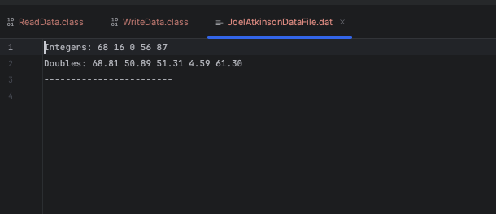
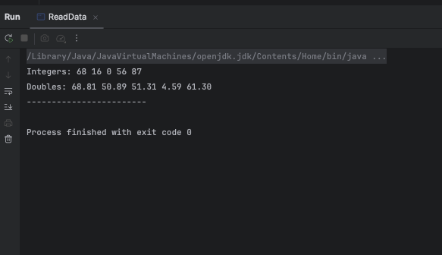
Screenshot of Output when running ReadData.java:

Screenshot of output when running WriteData.java:
